Chapter 2

What is java
Java is:
 A new Object Oriented Programming Language developed at Sun Microsystems.
 Easier to learn than most other Object Oriented programming languages,
sinceit has collected the best parts of the existing ones.
 A language that is standardized enough so that executable applications can run on any (in principle) computer that contains a Virtual Machine (run-time environment).
 Virtual machines can be embedded in web browsers (such as Netscape Navigator, Microsoft Internet Explorer, and IBM Web Explorer) and operating systems.
 A standardized set of Class Libraries (packages), that support creating graphical user interfaces, controlling multimedia data and communicating over networks.
  A programming language that supports the most recent features in computer science at the programming language level.
Java is not:
  Slower than any other Object Oriented language. Java applications can always be compiled to native code and run as fast as any other program.
  100% compatible yet, since the same application does not always look the

same on all platforms due to virtual machine implementation bugs and differences.
1.1 Different kinds of Java applications
Java applications can be of several kinds. The three main ones treated here
 Programs with a textual interface.
 Applets used in Internet browsers.
 Windowing applications that use a graphical user interface.

1.2 Platform independence
Platform independence means that the same (compiled) program can be executed on any computer.
It is obvious that this is necessary in Internet applications, since any kind of machine may be used to see WWW pages. This is why most recent Internet browsers include a Java Virtual Machine (JVM) that executes instructions generated by a Java compiler.
This Java virtual machine can also be incorporated or embedded into the kernel of the operating system. Java virtual machines nowadays exist for most operating systems.
We call the JVM a virtual machine because the Java compiler produces compiled code whose target machine is this virtual machine instead of being a physical processor or computer. A Java program is said to be compiled to byte-codes, whose target architecture is the Java Virtual Machine, as illustrated by Figure .

Java source

Java Byte code
Environment
Java VM

javac

.class .java
Figure . Compilation of a Java program to byte-codes and executing
it with the Java VM.
Figure also shows the development process a typical Java programmer uses to produce byte codes and execute them. The first box indicates that the Java source code is located in a “.java” file, which is processed with a Java compiler called “javac”. The Java compiler produces a file called a “.class” file, which contains the byte code. The “.class” file is then loaded across the network or loaded locally on your machine into the execution environment on that platform. Inside that environment is the Java virtual machine, which interprets and executes the byte code.

Chapter 3
Java development tools

Sun is the main distributor of Java development tools. These tools are use for development the java based application, which are run on number of platforms.

The Java Development Kit (JDK)
The JDK contains everything you need to develop general-purpose programs in Java:

  Base Tools
  javac: The Java Language Compiler that you use to compile programs written
in the Java(tm) Programming Language into byte codes.
  java: The Java Interpreter that you use to run programs written in the Java(tm)
Programming Language.
  jre: The Java Runtime Interpreter that you can use to run Java applications.
The jre tool is similar to the java tool, but is intended primarily for end users
who do not require all the development-related options available with the java
tool.
  jdb: The Java Language Debugger that helps you find and fix bugs in Java(tm)
programs.

  javah: Creates C header files and C stub files for a Java(tm) class. These files
provide the connective glue that allow your code written in the Java Programming
Language to interact with code written in other languages like C.
  javap: Disassembles compiled Java(tm) files and prints out a representation of the Java bytecodes.
  javadoc: Generates API documentation in HTML format from Java(tm) source code.
  appletviewer: Allows you to run applets without a web browser.
       RMI Tools
 rmic: Generates stub and skeleton class files for Java objects implementing  the java.rmi.Remote interface.
rmiregistry:  Starts a remote object registry on a specified port. The remote object registry is a bootstrap naming service which is used by RMI servers.
serialver:  Returns the serialVersionUID for one or more classes.

     Internationalization Tools
native2ascii: Converts non-Unicode Latin-1  (source code or property) files to
Unicode Latin-1.

  JAR Tool
jar:  Combines multiple files into a single Java Archive (JAR) file.

  Digital Signing Tool
 javakey: Generates digital signatures for archive files and manages the
database of entities and their keys and signatures.
  Environment Variables
 CLASSPATH: Tells the Java Virtual Machine and other Java applications where to find the class libraries.
If you have developed an application in Java and want to deploy it, you need to download the Java Runtime Environment (JRE), which contains only what is necessary for running a Java application (JVM and libraries), but no development tools. It may be freely distributed with your application.
It is possible to use the JDK as the only development environment for any development project. It is, however, useful to create straight away at least the following two script files for each project:
 makeit.bat: Contains the command line for compiling the whole project. It may be useful to associate this with using various "make" tools for project management.
 runit.bat: Launches the program.

Chapter 4
Features of java

Supporting oops features
A class is a template that defines how an object will look and behave once instantiated.
In this course, we will use cars as an example of a system with various objects that interact with each other. A car contains subsystems, which may be considered as objects:
Injection system. 
Ignition system. 
Breaking system  (including ABS).
Steering system. 
Others (have a look at  your car's fuse boxes to get an idea).
A class corresponds to the factory or machine that produces these subsystems. Once these subsystems are installed in a car, they become objects that communicate through well-defined protocols in such a way that (hopefully) makes the car work and makes it possible to drive with it.
In Object Oriented Programming (OOP), methods implement the communication protocol between the objects.
Only some of all the methods are visible to other objects. These are the public
methods. We also have private methods and private variables, which are only

visible to the object itself. These are used for the internal operations of the object.
This is called encapsulation in OOP. In a car, it means that there is no way for one subsystem to interfere with the internal functioning of another one. This is natural, since there is no way why the injection system should have access to the private calculations of the ABS system, for instance.
We may also have private classes. The ABS system might, for instance, be a private class to the breaking subsystem. It would then be directly accessible only to the breaking subsystem. Another important concept in OOP is inheritance. This means that we can define class hierarchies, where derived classes inherit behaviour from their base class. In a car, we could for instance say that the clutch, break and accelerator classes are all derived from the "PedalControlledDevice" base class. Then the "PedalControlledDevice" would define all the behaviour common to the derived classes.
The third classical concept in OOP is polymorphism, which means that we may have several methods which the same name, but with different parameters. This means that the actual behavior of the method depends on the kind of data that it works on. An example of this is the "toString()" method that is defined for all classes in Java and gives a textual description of the object, no matter what the type of the object is.

Applets
Most Java applications are still applets, i.e. usually small applications that are run inside a WWW browser like Netscape Navigator or Microsoft Internet Explorer.
Their main purposes are to present information in a user friendly and interactive

way. They are also used for animating Internet pages just in order to make them more interesting.

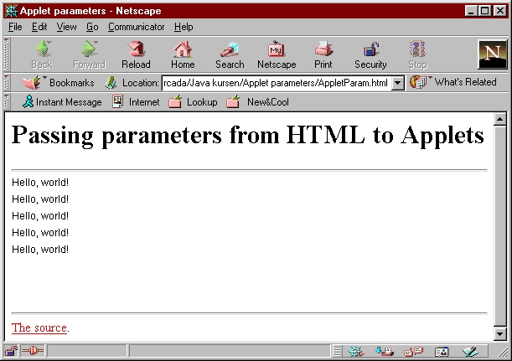

User Interaction
User interaction has changed greatly from version 1.0.x to 1.1.x. This especially concerns the handling of events.
The new model is much more flexible and simplifies writing well-structured, modular programs. Although version 1.1.x virtual machines have become a great majority,
We will stick to the 1.0.x event model in this course. This is to be sure that our applets
Will work fine even with older internet browsers.

Window Layout
Java applications should run in a similar way on any operating system. This means that the user interface should look about the same in all cases.
Unfortunately, different operating systems do not use exactly the same fonts, do not have the same window border widths or there might be other differences. All these factors make it difficult to know exactly how big our user interface should be and where they should be positioned.
Java window layout managers are used for avoiding these problems. The programmer just defines some rules for the positioning and sizing of the elements in relation to each other and/or to the window and the manager respects this as well as possible.

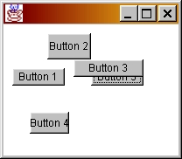

Abstract Classes and Interfaces
An abstract class is a class which only implements a part of the functions that it is intended for. One example of an abstract class could be a class for sorting objects (class "Sorter" for instance), which provides the sorting logic itself. Then a class

"IntSorter" would only need to provide one method for comparing two integers and another method for swapping those that are out of order. The sort logic is not written here, but that is not the main issue. The main issue is that we have a partial implementation (the sort logic) while some parts of the implementation have to be provided by derived classes. So the class "IntSorter" would have to provide an implementation for the methods that are declared abstract

